WEEK-6: User Account XML: Create an XML structure to store user account information, including details like username, password (encrypted), email, and purchase history.

1.The XML File (users.xml)

<?xml version="1.0" encoding="UTF-8"?>
<userAccounts>
<user id="u1">
<username>alice_smith</username> <password>5e884898da28047151d0e56f8dc6292773603d0d6aabbdd62a11ef721d1542d8</password>
<email>alice@example.com</email>
<purchaseHistory>
<purchase>
<itemName>Wireless Keyboard</itemName>
<price>$45.00</price>
<date>2026-03-15</date>
</purchase>
<purchase>
<itemName>USB-C Hub</itemName>
<price>$25.00</price>
<date>2026-04-02</date>
</purchase>
</purchaseHistory>
</user>
<user id="u2">
<username>bob_jones</username> <password>8d969eef6ecad3c29a3a629280e686cf0c3f5d5a86aff3ca12020c923adc6c92</password>
<email>bob.j@example.com</email>
<purchaseHistory>
<purchase>
<itemName>Ergonomic Mouse</itemName>
<price>$60.00</price>
<date>2026-04-05</date>
</purchase>
</purchaseHistory>
</user>
</userAccounts>

2. Page 1: User Directory (index.html)

<!DOCTYPE html>
<html lang="en">
<head>
<meta charset="UTF-8">
<title>User Directory</title>
<style>
body { font-family: Arial, sans-serif; padding: 20px; background: #f4f4f9; }
.user-card { background: white; padding: 15px; margin-bottom: 10px; border-radius: 5px; box-shadow: 0 2px 4px rgba(0,0,0,0.1); }
a { text-decoration: none; color: white; background: #007bff; padding: 5px 10px; border-radius: 3px; font-size: 14px; }
</style>
</head>
<body>

<h2>User Accounts Dashboard</h2>
<div id="users-container">Loading users...</div>

<script>
fetch('users.xml')
.then(response => response.text())
.then(data => {
const parser = new DOMParser();
const xml = parser.parseFromString(data, "application/xml");
const users = xml.querySelectorAll('user');
let output = '';

users.forEach(user => {
const id = user.getAttribute('id');
const username = user.querySelector('username').textContent;
const email = user.querySelector('email').textContent;

output += `
<div class="user-card">
<h3>${username}</h3>
<p>Email: ${email}</p>
<a href="history.html?id=${id}">View Purchase History</a>
</div>
`;
});
document.getElementById('users-container').innerHTML = output;
});
</script>
</body>
</html>

3. Page 2: Purchase History (history.html)

<!DOCTYPE html>
<html lang="en">
<head>
<meta charset="UTF-8">
<title>Purchase History</title>
<style>
body { font-family: Arial, sans-serif; padding: 20px; background: #f4f4f9; }
.purchase { background: white; padding: 10px; margin-bottom: 5px; border-left: 4px solid #28a745; }
a.back { display: inline-block; margin-bottom: 15px; color: #007bff; text-decoration: none; }
</style>
</head>
<body>

<a href="index.html" class="back">← Back to Directory</a>
<h2 id="user-title">Purchase History</h2>
<div id="history-container">Loading...</div>

<script>
// Get the user ID from the URL (e.g., ?id=u1)
const params = new URLSearchParams(window.location.search);
const userId = params.get('id');

fetch('users.xml')
.then(response => response.text())
.then(data => {
const parser = new DOMParser();
const xml = parser.parseFromString(data, "application/xml");

// Find the specific user by ID
const user = xml.querySelector(`user[id="${userId}"]`);

if (!user) {
document.getElementById('history-container').innerHTML = "<p>User not found.</p>";
return;
}

const username = user.querySelector('username').textContent;
document.getElementById('user-title').textContent =`Purchase History for ${username}`;
const purchases = user.querySelectorAll('purchaseHistory purchase');
let output = '';

if (purchases.length === 0) {
output = "<p>No purchases found.</p>";
} else {
purchases.forEach(p => {
const item = p.querySelector('itemName').textContent;
const price = p.querySelector('price').textContent;
const date = p.querySelector('date').textContent;

output += `
<div class="purchase">
<strong>${item}</strong> - ${price} <br>
<small>Purchased on: ${date}</small>
</div>
`;
});
}
document.getElementById('history-container').innerHTML = output;
});
</script>
</body>
</html>

OUTPUT

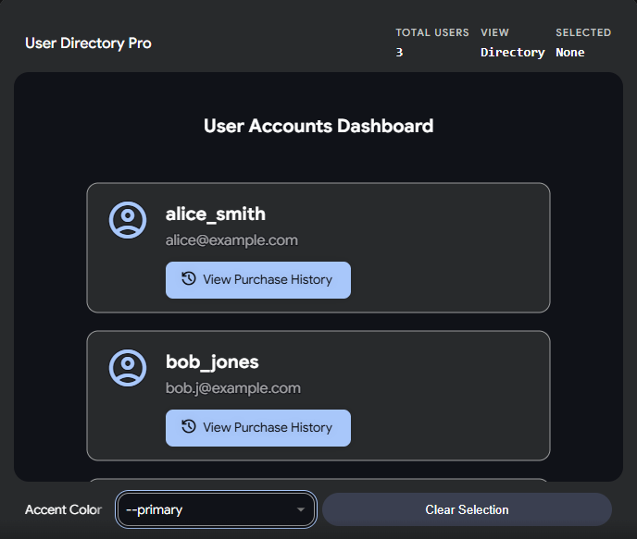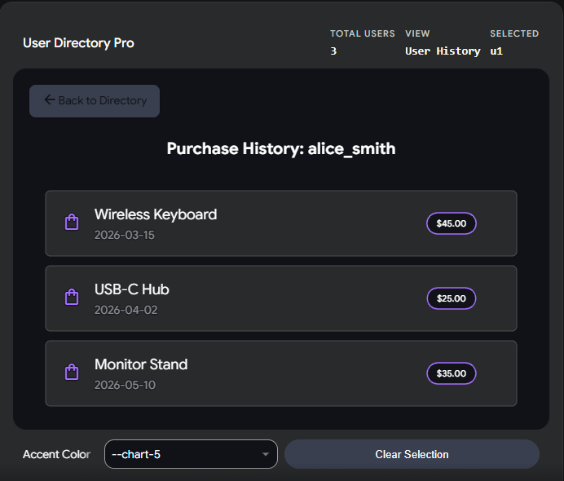

WEEK-7: Install and configure Apache Tomcat server in Eclipse

Step 1: Install Apache Tomcat (outside Eclipse)

Step 2: Open Eclipse in Java EE Perspective

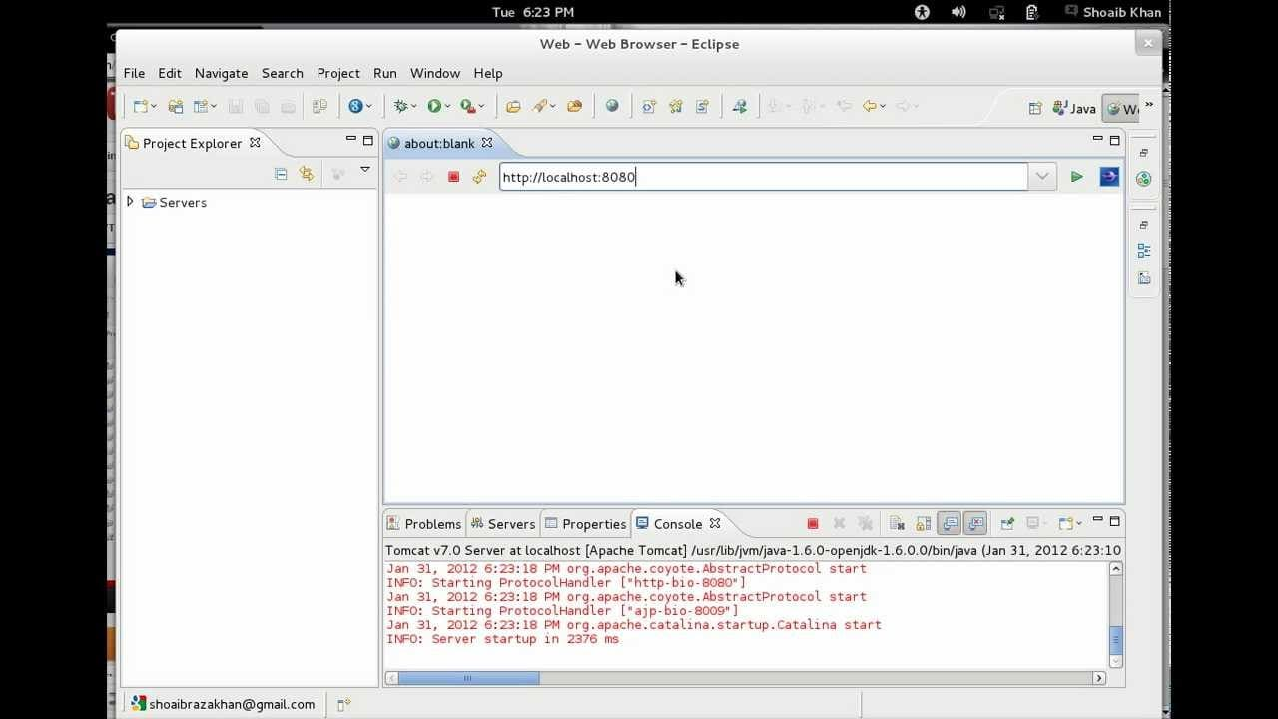

Step 3: Add Tomcat Server Runtime

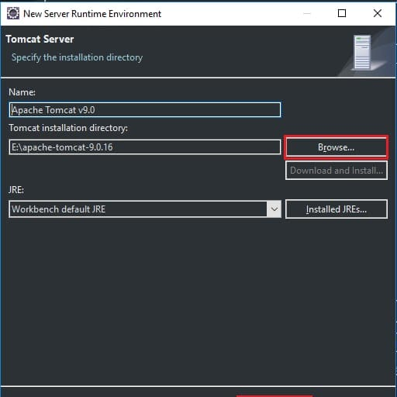

Step 4: Create a Tomcat Server in Eclipse

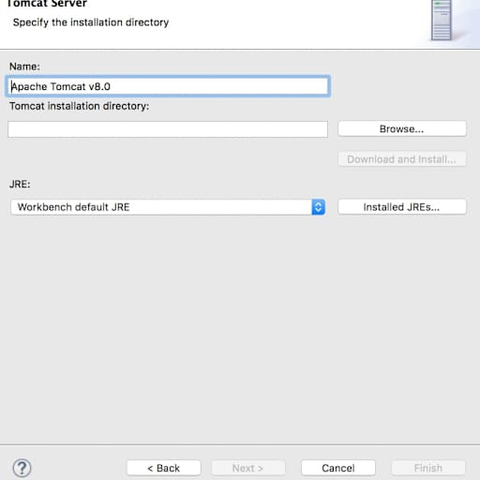

Step 5: Start the Tomcat Server

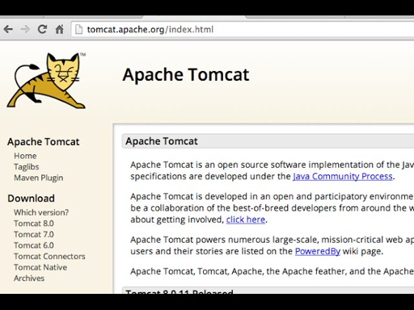

Step 6: Create a Simple Web Project and Deploy on Tomcat

Step 7: Verify Everything is Working

WEEK-8: Servlet for Book Retrieval: Develop a servlet that retrieves book information from a database and sends it to the content frame.

1.Database Setup (SQL)

CREATE TABLE books (
id INT PRIMARY KEY,
title VARCHAR(100),
author VARCHAR(100),
year INT
);

INSERT INTO books VALUES (1, 'Clean Code', 'Robert C. Martin', 2008);
INSERT INTO books VALUES (2, 'The Pragmatic Programmer', 'Andrew Hunt', 1999);
INSERT INTO books VALUES (3, 'Design Patterns', 'Erich Gamma', 1994);

2. Main Layout (index.html)

<!DOCTYPE html>
<html>
<head>
<title>Book Library</title>
</head>
<frameset cols="20%, 80%">
<frame src="nav.html" name="navFrame">
<frame src="content.html" name="contentFrame">
</frameset>
</html>

3. Navigation Frame (nav.html)

<!DOCTYPE html>
<html>
<body style="font-family: Arial, sans-serif; background-color: #f4f4f4;">
<h3>Menu</h3>
<a href="BookServlet" target="contentFrame">View All Books</a>
</body>
</html>

4. The Servlet (BookServlet.java)

import java.io.*;
import java.sql.*;
import javax.servlet.*;
import javax.servlet.http.*;
public class BookServlet extends HttpServlet {
public void doGet(HttpServletRequest request, HttpServletResponse response)
throws ServletException, IOException {
response.setContentType("text/html");
PrintWriter out = response.getWriter();
out.println("<html><head><style>table {width: 100%; border-collapse: collapse;} th, td {border: 1px solid black; padding: 8px; text-align: left;} th {background-color: #f2f2f2;}</style></head><body>");
out.println("<h2>Book List</h2>
try {
// 1. Load Driver (Example for MySQL)
Class.forName("com.mysql.cj.jdbc.Driver");

// 2. Connect to DB (Change URL, username, password!)
Connection con = DriverManager.getConnection("jdbc:mysql://localhost:3306/yourdb", "root", "password");

// 3. Execute Query
Statement stmt = con.createStatement();
ResultSet rs = stmt.executeQuery("SELECT * FROM books");

// 4. Print HTML Table
out.println("<table><tr><th>ID</th><th>Title</th><th>Author</th><th>Year</th></tr>");
while (rs.next()) {
out.println("<tr>");
out.println("<td>" + rs.getInt("id") + "</td>");
out.println("<td>" + rs.getString("title") + "</td>");
out.println("<td>" + rs.getString("author") + "</td>");
out.println("<td>" + rs.getInt("year") + "</td>");
out.println("</tr>");
}
out.println("</table>");

con.close();
} catch (Exception e) {
out.println("<p>Error: " + e.getMessage() + "</p>");
}

out.println("</body></html>");
}
}

OUTPUT

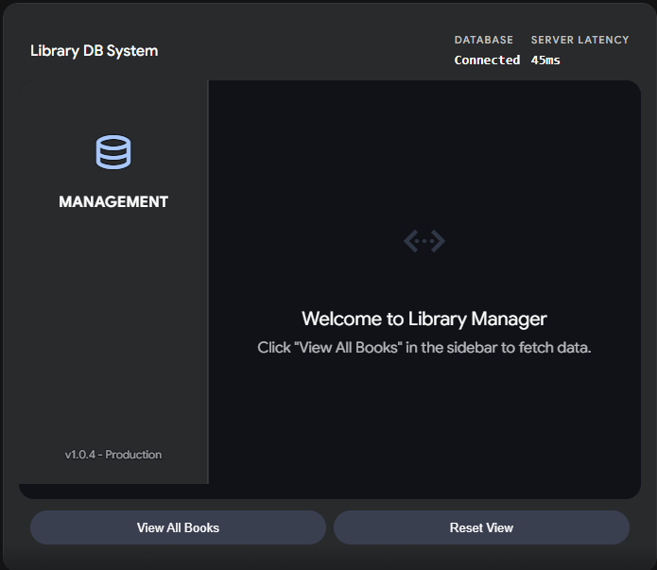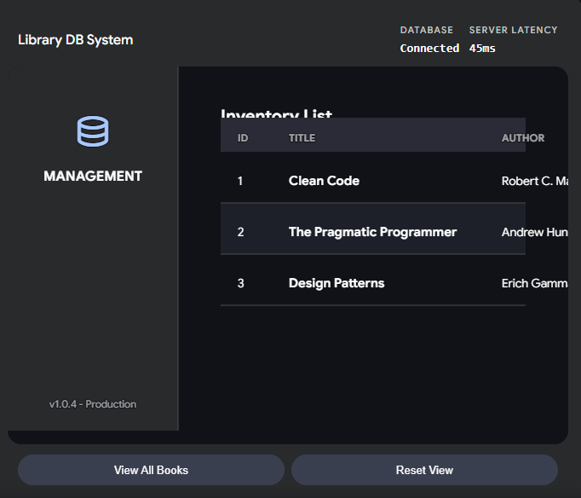

WEEK-9: User Authentication: Implement user authentication using servlets and JSP. Create a login page and restrict access to certain pages for authenticated users.

1.The Login Page (login.jsp)

<%@ page language="java" contentType="text/html; charset=UTF-8" pageEncoding="UTF-8"%>
<!DOCTYPE html>
<html>
<head>
<title>Login</title>
<style>
body { font-family: Arial, sans-serif; background: #f4f4f9; display: flex; justify-content: center; padding-top: 50px; }
.login-box { background: white; padding: 20px; border-radius: 5px; box-shadow: 0 0 10px rgba(0,0,0,0.1); width: 300px; }
input[type="text"], input[type="password"] { width: 90%; padding: 10px; margin: 10px 0; }
button { width: 100%; padding: 10px; background: #007bff; color: white; border: none; cursor: pointer; }
.error { color: red; font-size: 14px; }
</style>
</head>
<body>
<div class="login-box">
<h2>Sign In</h2>
<% if(request.getAttribute("error") != null) { %>
<p class="error"><%= request.getAttribute("error") %></p>
<% } %>
<form action="LoginServlet" method="post">
<input type="text" name="username" placeholder="Username" required><br>
<input type="password" name="password" placeholder="Password" required><br>
<button type="submit">Login</button>
</form>
</div>
</body>
</html>

2. The Authentication Servlet (LoginServlet.java)

import java.io.IOException;
import javax.servlet.ServletException;
import javax.servlet.annotation.WebServlet;
import javax.servlet.http.*;
@WebServlet("/LoginServlet")
public class LoginServlet extends HttpServlet {
protected void doPost(HttpServletRequest request, HttpServletResponse response)
throws ServletException, IOException {
String user = request.getParameter("username");
String pass = request.getParameter("password");
// Hardcoded check (Replace with DB validation in production)
if ("admin".equals(user) && "password123".equals(pass)) {
// Create a session and store the username
HttpSession session = request.getSession();
session.setAttribute("username", user);
// Redirect to the restricted page
response.sendRedirect("dashboard.jsp");
} else {
// Send back to login page with an error
request.setAttribute("error", "Invalid username or password");
request.getRequestDispatcher("login.jsp").forward(request, response);
}
}
}

3. The Restricted Page (dashboard.jsp)

<%@ page language="java" contentType="text/html; charset=UTF-8" pageEncoding="UTF-8"%>
<%
// Security Check: Restrict access to authenticated users only
if (session.getAttribute("username") == null) {
response.sendRedirect("login.jsp");
return; // Stop rendering the page
}
%>
<!DOCTYPE html>
<html>
<head>
<title>Dashboard - Restricted Area</title>
<style>
body { font-family: Arial, sans-serif; padding: 20px; text-align: center; }
.card { background: #e0f7fa; padding: 20px; display: inline-block; border-radius: 8px; }
a.logout { color: white; background: #dc3545; padding: 8px 15px; text-decoration: none; border-radius: 4px; }
</style>
</head>
<body>
<div class="card">
<h2>Welcome, <%= session.getAttribute("username") %>!</h2>
<p>You have successfully accessed the restricted dashboard.</p>
<br>
<a href="LogoutServlet" class="logout">Logout</a>
</div>
</body>
</html>

4. The Logout Servlet (LogoutServlet.java)

import java.io.IOException;
import javax.servlet.ServletException;
import javax.servlet.annotation.WebServlet;
import javax.servlet.http.*;
@WebServlet("/LogoutServlet")
public class LogoutServlet extends HttpServlet {
protected void doGet(HttpServletRequest request, HttpServletResponse response)
throws ServletException, IOException {
HttpSession session = request.getSession(false); // Get existing session
if (session != null) {
session.invalidate(); // Destroy the session
}
response.sendRedirect("login.jsp");
}
}

OUTPUT

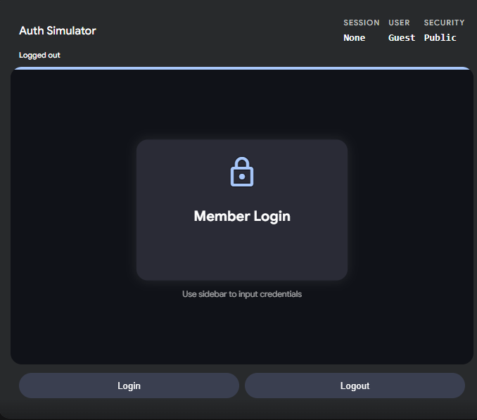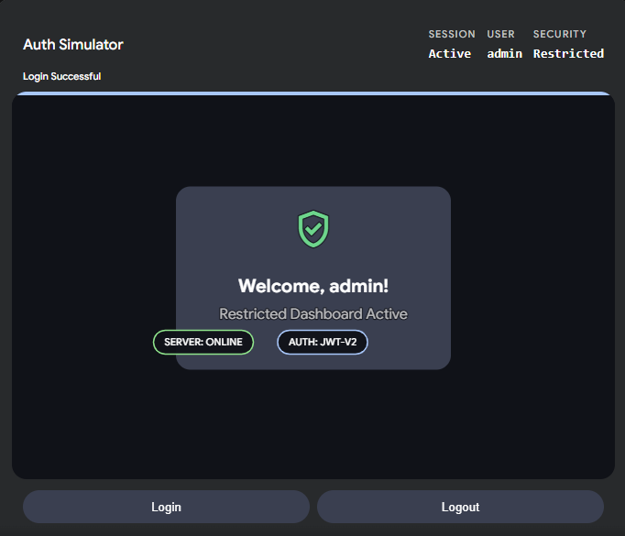

WEEK-10:
Hibernate: Hibernate Entity Mapping: Create Hibernate entity classes to represent
books and users. Map these entities to corresponding database tables

1.The Book Entity (Book.java)

import javax.persistence.*;
@Entity
@Table(name = "books")
public class Book {
@Id // Marks this as the Primary Key
@GeneratedValue(strategy = GenerationType.IDENTITY) // Auto-increments the ID
@Column(name = "book_id")
private int id;
@Column(name = "title", nullable = false, length = 100)
private String title;
@Column(name = "author", length = 100)
private String author;
@Column(name = "published_year")
private int year;
// Default constructor is required by Hibernate
public Book() {}
// Getters and Setters
public int getId() { return id; }
public void setId(int id) { this.id = id; }
public String getTitle() { return title; }
public void setTitle(String title) { this.title = title; }
public String getAuthor() { return author; }
public void setAuthor(String author) { this.author = author; }
public int getYear() { return year; }
public void setYear(int year) { this.year = year; }
}

2. The User Entity (User.java)

import javax.persistence.*;
@Entity
@Table(name = "users")
public class User {
@Id
@GeneratedValue(strategy = GenerationType.IDENTITY)
@Column(name = "user_id")
private int id;
@Column(name = "username", unique = true, nullable = false, length = 50)
private String username;

@Column(name = "password", nullable = false) // Passwords should ideally be hashed
private String password;
@Column(name = "email", length = 100)
private String email;
// Default constructor is required by Hibernate
public User() {}
// Getters and Setters
public int getId() { return id; }
public void setId(int id) { this.id = id; }
public String getUsername() { return username; }
public void setUsername(String username) { this.username = username; }
public String getPassword() { return password; }
public void setPassword(String password) { this.password = password; }
public String getEmail() { return email; }
public void setEmail(String email) { this.email = email; }
}

OUTPUT

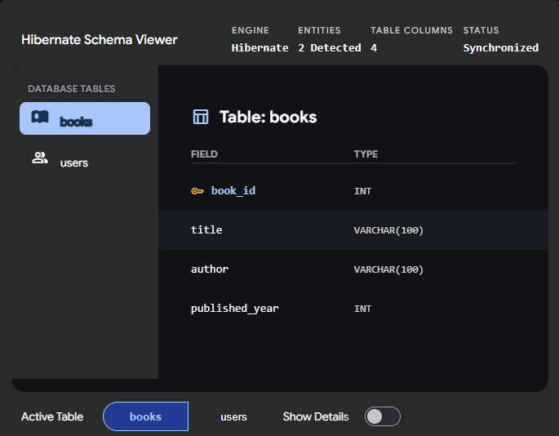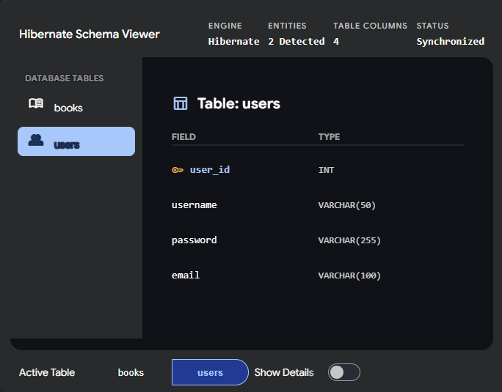

WEEK-11:
CRUD Operations: Implement CRUD operations using Hibernate for managing book
information in the database.

1.The Database Helper (HibernateUtil.java)

import org.hibernate.SessionFactory;
import org.hibernate.cfg.Configuration;
public class HibernateUtil {
private static final SessionFactory sessionFactory;
static {
try {
// Loads configuration and builds the session factory
sessionFactory = new Configuration().configure().buildSessionFactory();
} catch (Throwable ex) {
System.err.println("Initial SessionFactory creation failed." + ex);
throw new ExceptionInInitializerError(ex);
}
}

public static SessionFactory getSessionFactory() {
return sessionFactory;
}
}

2. The CRUD Implementation (BookDAO.java)

import org.hibernate.Session;
import org.hibernate.Transaction;
import java.util.List;
public class BookDAO {
// ---------------------------------------------------------
// CREATE: Add a new book to the database
// ---------------------------------------------------------
public void saveBook(Book book) {
Transaction transaction = null;
try (Session session = HibernateUtil.getSessionFactory().openSession()) {
transaction = session.beginTransaction();
session.save(book); // Hibernate automatically writes the INSERT SQL
transaction.commit();
} catch (Exception e) {
if (transaction != null) {
transaction.rollback(); // Undo changes if something goes wrong
}
e.printStackTrace();
}
}

// ---------------------------------------------------------
// READ: Get a specific book by its ID
// ---------------------------------------------------------
public Book getBook(int id) {
try (Session session = HibernateUtil.getSessionFactory().openSession()) {
return session.get(Book.class, id); // Hibernate writes the SELECT SQL
}
}

// ---------------------------------------------------------
// READ: Get a list of all books in the database
// ---------------------------------------------------------
@SuppressWarnings("unchecked")
public List<Book> getAllBooks() {
try (Session session = HibernateUtil.getSessionFactory().openSession()) {
// HQL (Hibernate Query Language) uses the Java class name, not the DB table name
return session.createQuery("from Book").list();
}
}

// ---------------------------------------------------------
// UPDATE: Modify an existing book's details
// ---------------------------------------------------------
public void updateBook(Book book) {
Transaction transaction = null;
try (Session session = HibernateUtil.getSessionFactory().openSession()) {
transaction = session.beginTransaction();
session.update(book); // Hibernate writes the UPDATE SQL
transaction.commit();
} catch (Exception e) {
if (transaction != null) {
transaction.rollback();
}
e.printStackTrace();
}
}

// ---------------------------------------------------------
// DELETE: Remove a book from the database
// ---------------------------------------------------------
public void deleteBook(int id) {
Transaction transaction = null;
try (Session session = HibernateUtil.getSessionFactory().openSession()) {
transaction = session.beginTransaction();

// First, fetch the book we want to delete
Book book = session.get(Book.class, id);
if (book != null) {
session.delete(book); // Hibernate writes the DELETE SQL
}

transaction.commit();
} catch (Exception e) {
if (transaction != null) {
transaction.rollback();
}
e.printStackTrace();
}
}
}

OUTPUT
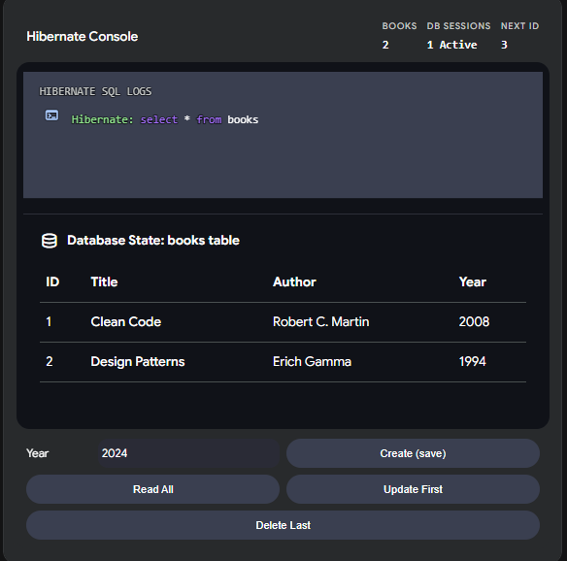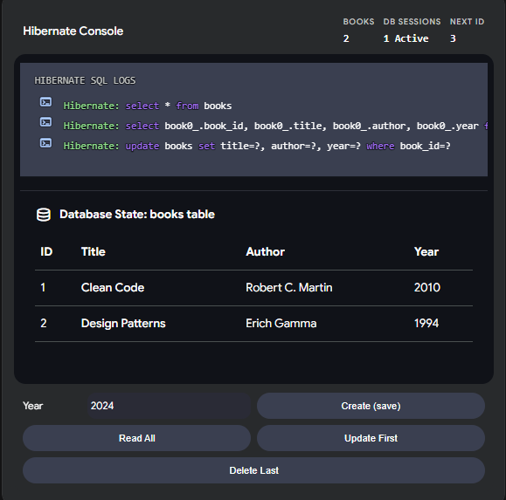

WEEK-12: Full-Stack Integration: Integrate JavaScript with Servlets: Enhance the shopping cart functionality by integrating JavaScript with servlets. Allow users to update the cart without page refresh.

1.The Frontend (cart.jsp)

<!DOCTYPE html>
<html>
<head>
<title>AJAX Shopping Cart</title>
<style>
body { font-family: Arial, sans-serif; padding: 20px; max-width: 500px; }
.cart-item { padding: 10px; border-bottom: 1px solid #ddd; display: flex; justify-content: space-between; align-items: center; }
.cart-item input { width: 50px; padding: 5px; }
.status-message { color: #28a745; font-size: 14px; display: none; margin-bottom: 10px; }
.total-row { margin-top: 20px; font-size: 1.2em; font-weight: bold; text-align: right; }
</style>
</head>
<body>

<h2>Your Shopping Cart</h2>
<div id="updateStatus" class="status-message">Cart updated successfully!</div>

<div class="cart-item">
<span>Clean Code ($40.00)</span>
<input type="number" value="1" min="1" onchange="updateCart(1, 40.00, this.value)">
</div>
<div class="cart-item">
<span>Design Patterns ($50.00)</span>
<input type="number" value="1" min="1" onchange="updateCart(2, 50.00, this.value)">
</div>

<div class="total-row">
Total: $<span id="cartTotal">90.00</span>
</div>

<script>
// JavaScript for asynchronous updating (AJAX)
function updateCart(bookId, price, quantity) {
// Send a background request to the Servlet
fetch('CartServlet', {
method: 'POST',
headers: { 'Content-Type': 'application/x-www-form-urlencoded' },
body: `bookId=${bookId}&price=${price}&quantity=${quantity}`
})
.then(response => response.json()) // The Servlet will return JSON data
.then(data => {
// Update the total on the screen dynamically
document.getElementById('cartTotal').innerText = data.newTotal;

// Flash a success message
let status = document.getElementById('updateStatus');
status.style.display = 'block';
setTimeout(() => { status.style.display = 'none'; }, 2000); // Hide after 2 seconds
})
.catch(error => console.error('Error updating cart:', error));
}
</script>
</body>
</html>

2. The Backend (CartServlet.java)

import java.io.*;
import javax.servlet.*;
import javax.servlet.annotation.WebServlet;
import javax.servlet.http.*;
@WebServlet("/CartServlet")
public class CartServlet extends HttpServlet {
protected void doPost(HttpServletRequest request, HttpServletResponse response)
throws ServletException, IOException {
// 1. Read the parameters sent by Javascript
int bookId = Integer.parseInt(request.getParameter("bookId"));
double price = Double.parseDouble(request.getParameter("price"));
int quantity = Integer.parseInt(request.getParameter("quantity"));
// 2. Business Logic: Update session cart and recalculate total
// Note: For this isolated example, we are just calculating the total of the changed item.
// In a real app, you would retrieve the user's cart object from the session and sum all items.
HttpSession session = request.getSession();
// Simulating a cart total calculation (Assuming they only have this one item type for the demo math)
// You would replace this with actual cart iteration logic.
double simulatedNewTotal = price * quantity;
// 3. Set the response content type to JSON
response.setContentType("application/json");
response.setCharacterEncoding("UTF-8");

// 4. Send the JSON response back to the Javascript fetch() call
PrintWriter out = response.getWriter();
out.print("{\"newTotal\": \"" + String.format("%.2f", simulatedNewTotal) + "\"}");
out.flush();
}
}

OUTPUT

